CHAPTER- 1
INTRODUCTION TO THE PROJECT
The Task Management System helps teams effectively manage tasks, providing features such as task prioritization, file attachments, task status tracking, team collaboration, and real-time updates. Admins can create tasks, assign them to users, and track task progress. Additionally, the system provides a Kanban board view for task visualization.


Fig.1.1. Task Management System Logo

The main features of this app are: -
User Authentication
- Login/Signup: Users can register and log in using email/password or social logins (LinkedIn, GitHub, Google OAuth).
- User Roles: Users are assigned roles (Admin, User), with admins having control over task management and team collaboration.
Task Management
- Create Tasks: Admins can create tasks with priority levels (High, Medium, Low), labels, due dates, and file attachments. Tasks are saved in MongoDB and assigned to users.
- Update Tasks: Admins can modify task details such as priority, status, assigned user, and deadlines.
- Delete Tasks: Admins can delete tasks.
- View Tasks: Both users and admins can view tasks, with user-specific tasks shown on their dashboard.
Team Collaboration
- Task Assignment: Admins can assign tasks to users. Users see the tasks assigned to them on their personal dashboard.
- Real-time Updates: Task updates are reflected in real-time across all user dashboards.
File Attachments
- Task Files: Users can upload files (images, documents) to tasks. Files are stored in Cloudinary.
- Preview/Download: Users can preview or download the files associated with tasks.
Task Status Tracking
- Task Status: Tasks can be marked as "To-Do," "Active," or "Completed." Both admins and users can update task statuses.
- Priority: Each task is assigned a priority: high, medium, or low.

Kanban Board
- Kanban View: The Admin Dashboard features a Kanban board for tasks, allowing users to visually track task progress and status.
AI-based Insights (Optional)
- AI Insights: Admins can use AI to analyze task data and generate insights regarding team productivity, task completion rates, and other metrics.

CHAPTER- 2
TOOL AND TECHNOLOGY
2.1. WEB TECHNOLOGIES USED
In the development of our web-based platform, a modern and efficient technology stack has been adopted to ensure seamless performance, scalability, and an optimal user experience. Below is a detailed overview of the technologies employed across various layers of the application.

2.1.1 React.js (Frontend)
- A JavaScript library developed by Facebook for building fast, interactive, and scalable user interfaces.
- Utilizes a component-based architecture that promotes code reusability and modular design.
- Uses a Virtual DOM to efficiently update only the necessary parts of the page, improving performance.
- Supports hooks and modern JavaScript features like ES6+, enabling functional and clean code.
- Has a large ecosystem and community support, along with powerful developer tools.

2.1.2 Node.js & Express (Backend)
- Node.js allows JavaScript to run on the server, enabling full-stack development with a single language.
- Built on Chrome’s V8 engine, it offers asynchronous, non-blocking I/O operations for high scalability.
- Express is a minimalist web framework for Node.js, simplifying routing, middleware handling, and API development.
- Provides easy integration with databases, file systems, and authentication modules.
- Offers flexibility for building RESTful APIs and microservices architecture.

2.1.3 MongoDB (Database)
- A NoSQL, document-oriented database that stores data in flexible, JSON-like documents (BSON).
- Schema-less design allows developers to store different fields and types within a document, ideal for agile development.
- Supports indexing, replication, and sharding for performance, high availability, and scalability.
- Integrates easily with Node.js applications using Mongoose or native MongoDB drivers.
- Ideal for real-time applications that require large volumes of unstructured data.

2.1.4 Tailwind CSS & Material UI (Styling)
- Tailwind CSS: A utility-first CSS framework that allows fast UI development with pre-defined classes.
- Reduces the need for writing custom CSS by letting developers style directly within HTML/JSX elements.
- Enables responsive design with built-in breakpoints and mobile-first utilities.
- Material UI: A component library that implements Google's Material Design with ready-made components.
- Ensures visual consistency, accessibility, and responsive behavior across devices.

2.1.5 Cloudinary (File/Image Uploads)
- A cloud-based service for managing images and video uploads, transformations, and delivery.
- Offers automatic optimization for faster load times and improved performance across devices.
- Supports powerful transformations (resize, crop, watermark) through simple URL parameters or APIs.
- Provides secure upload options with signed URLs and access control.
- Integrates with frontend and backend easily via SDKs and REST APIs.

2.1.6 Redux / Context API (State Management)
- Redux: A predictable state container for JavaScript apps that helps manage complex state logic.
- Centralizes the application state in a single store, making debugging and tracking easier.
- Uses actions and reducers to handle state transitions in a clear, structured manner.
- Context API: A simpler, built-in alternative for passing data deeply through the component tree without prop drilling.
- Ideal for managing global state like themes, user authentication, or settings.

2.1.7 Multer (Middleware for File Handling)
- A middleware for handling multipart/form-data, mainly used for uploading files in Node.js.
- Works seamlessly with Express, storing files on disk or in memory based on configuration.
- Provides filtering and validation options for file types, size limits, and field names.
- Can be combined with Cloudinary or AWS S3 for cloud storage integration.
- Supports single, multiple, or mixed file uploads efficiently.

2.1.8 Vercel / Netlify & Render (Deployment)
- Vercel: Optimized for React and frontend frameworks, it supports serverless functions and instant rollbacks.
- Netlify: Offers CI/CD pipelines, global CDN, and backend support through functions and form handling.
- Both platforms allow easy GitHub integration for automatic deployment on push.
- Render: Provides backend deployment, database hosting, and cron jobs — suitable for full-stack apps.
- All platforms support environment variables, HTTPS, custom domains, and analytics.

2.1. DEVELOPMENT TOOLS

To build, test, deploy, and maintain a robust web application, various development tools are utilized throughout the software development lifecycle. These tools enhance productivity, improve code quality, simplify debugging, and streamline collaboration among team members. Below is a detailed explanation of the key development tools used:

2.2.1 Visual Studio Code (VS Code)
- Lightweight yet powerful source code editor developed by Microsoft.
- Offers IntelliSense for smart completions based on variable types, function definitions, and imported modules.
- Built-in terminal allows developers to run scripts, Git commands, and server instances.
- Debugging features include breakpoints, variable watching, and call stack inspection.
- Rich extension ecosystem (e.g., Prettier, ESLint, GitLens) enhances functionality.
- Integrated Git support enables commit, push, pull, and conflict resolution.
- Supports real-time collaboration using the Live Share extension.
- Highly customizable through themes, keybindings, and settings.

2.2.2 Git & GitHub
- Git is a distributed version control system used to track code changes over time.
- Supports branching, merging, and reverting to previous versions of code.
- GitHub is a remote repository hosting service enabling collaboration on codebases.
- Offers pull requests, issues, project boards, and code reviews.
- Supports GitHub Actions for CI/CD automation.
- Enables team collaboration through role-based permissions and protected branches.
- Allows integration with third-party tools such as Slack, VS Code, and Trello.
- Facilitates open-source contribution and community involvement.

2.2.3 Postman
- API client that allows developers to create, test, and document APIs easily.
- Supports all HTTP methods (GET, POST, PUT, DELETE, PATCH, etc.).
- Provides environment variables for scalable and reusable API tests.
- Built-in scripting (pre-request and test scripts) using JavaScript.
- Enables team collaboration via collections, shared environments, and workspaces.
- Visual interface for inspecting headers, status codes, and response data.
- Supports automated testing and integration with CI/CD pipelines.
- Useful for mocking APIs during frontend development.

2.2.4 MongoDB Compass
- GUI tool for interacting with MongoDB databases visually.
- Allows data inspection, document editing, and custom queries without needing the terminal.
- Provides schema analysis and visualizes data structure and types.
- Enables users to create indexes to optimize query performance.
- Monitors real-time server statistics like memory usage and connection count.
- Allows easy connection setup for local and remote MongoDB instances.
- Facilitates export/import of data collections for backups or migrations.
- Speeds up development by providing a user-friendly interface for NoSQL data.

2.2.5 Nodemon
- Monitors for changes in source files of a Node.js app and automatically restarts the server.
- Saves time by eliminating the need for manual restarts during development.
- Ideal for Express.js and backend development workflows.
- Supports configuration via a nodemon.json file for custom behavior.
- Can be combined with tools like concurrently for multi-process apps.
- Works well in both JavaScript and TypeScript projects.
- Outputs real-time log messages, making debugging faster.
- Lightweight and easy to integrate with existing Node projects.

2.2.6 Webpack / Vite
- Webpack is a module bundler that processes JavaScript, CSS, and image assets.
- Supports tree shaking to eliminate unused code from bundles.
- Provides Hot Module Replacement (HMR) for faster development feedback.
- Vite uses native ES modules and improves cold-start and rebuild times.
- Enables code splitting and lazy loading for optimized performance.
- Allows the use of plugins for advanced build customizations.
- Supports both development and production environments seamlessly.
- Widely used in React, Vue, and other frontend frameworks.

2.2.7 ESLint & Prettier
- ESLint detects code issues and enforces consistent coding standards.
- Prettier auto-formats code to maintain visual consistency and readability.
- Prevents bugs by catching potential issues during development.
- Easily integrates into editors like VS Code and CI pipelines.
- Configurable rules and plugins to suit team or project style guides.
- Reduces code review overhead by automating formatting tasks.
- Supports JavaScript, TypeScript, JSX, and more.
- Encourages cleaner, maintainable, and error-free code.

2.2.8 Figma
- Cloud-based design tool for creating wireframes, UI mockups, and prototypes.
- Enables real-time collaboration with team members and stakeholders.
- Supports reusable design components for consistency across pages.
- Facilitates developer handoff with inspectable CSS and dimensions.
- Offers version history and auto-saving capabilities.
- Allows animations and interactions for clickable prototypes.
- Easy to share via links without software installation.
- Promotes faster iteration of UI/UX ideas.

2.2.9 Chrome Developer Tools
- Built into Google Chrome browser for inspecting and debugging web pages.
- DOM inspector allows real-time editing of HTML and CSS.
- JavaScript console enables code execution and debugging.
- Network tab visualizes requests and helps diagnose performance bottlenecks.
- Lighthouse audit tool evaluates performance, accessibility, SEO, and more.
- Device emulation mode tests responsiveness across screen sizes.
- Source tab allows debugging with breakpoints and variable watches.
- Critical for frontend development and troubleshooting.

2.2.10 Terminal / Command Line Interface (CLI)
- Central to development for executing scripts, version control, and package management.
- Allows launching development servers (e.g., npm start, nodemon app.js).
- Used for Git commands like clone, commit, push, and pull.
- Enables global installations and script execution for tools like ESLint or Prettier.
- Automates tasks through shell scripts and package.json scripts.
- Offers efficiency and speed over graphical interfaces.
- Used to navigate files, create projects, and run build commands.
- Essential for full-stack development workflows.

2.2.11 npm / yarn
- Package managers for installing and managing dependencies in JavaScript projects.
- Provide script execution for tasks like testing, building, and starting servers.
- Yarn offers faster performance through offline caching and parallel installation.
- Both support semantic versioning and lock files for consistency.
- Allow publishing and managing private/public packages.
- npm comes bundled with Node.js and is widely supported.
- Enable use of open-source libraries from the npm registry.
- Offer security audits and dependency tree visualization.

2.2.12 Render CLI / Vercel CLI / Netlify CLI
- Provide terminal-based deployment and configuration tools.
- Enable one-command deployment to respective hosting platforms.
- Support preview environments for staging and QA testing.
- Allow log viewing and real-time environment variable updates.
- Integrate with GitHub for continuous deployment.
- Handle both frontend static sites and backend APIs.
- Enable custom domain linking and SSL setup.
- Enhance developer productivity by streamlining deployment workflows.

2.2.13 Cloudinary Dashboard
- Visual dashboard to manage media files (images, videos, documents).
- Offers transformation presets like resizing, cropping, and format conversion.
- Provides CDN links for fast media delivery globally.
- Supports media optimization for different devices and networks.
- Allows secure API key management and usage tracking.
- Helps manage folders, tags, and upload presets efficiently.
- Enables previewing media changes in real-time.
- Useful for integration in both frontend and backend workflows.

2.2.14 Redux DevTools
- Browser extension to monitor Redux state changes in real-time.
- Displays dispatched actions and payloads clearly.
- Allows time-travel debugging and reverting to previous states.
- Useful for inspecting complex state logic and nested structures.
- Visualizes state tree and allows exporting/importing state.
- Filters and groups actions to manage large flows.
- Works seamlessly with Redux Toolkit and other middleware.
- Accelerates debugging in data-heavy applications.

2.2.15 Live Share (VS Code Extension)
- Enables real-time collaboration by sharing VS Code session live.
- Allows multiple developers to edit code, debug, and view files together.
- Supports shared terminal, debugging sessions, and server previews.
- Requires no repo cloning or file syncing for collaborators.
- Ensures privacy with customizable permission settings.
- Useful for pair programming, code reviews, and remote interviews.
- Works well across teams in different time zones or locations.
- Enhances productivity in collaborative development environments.

CHAPTER- 3
PROJECT STRUCTURE
Click on the start button to open main activity:-
Fig.3.1
- Click on the C language, java, Dbms button to open all questions:-
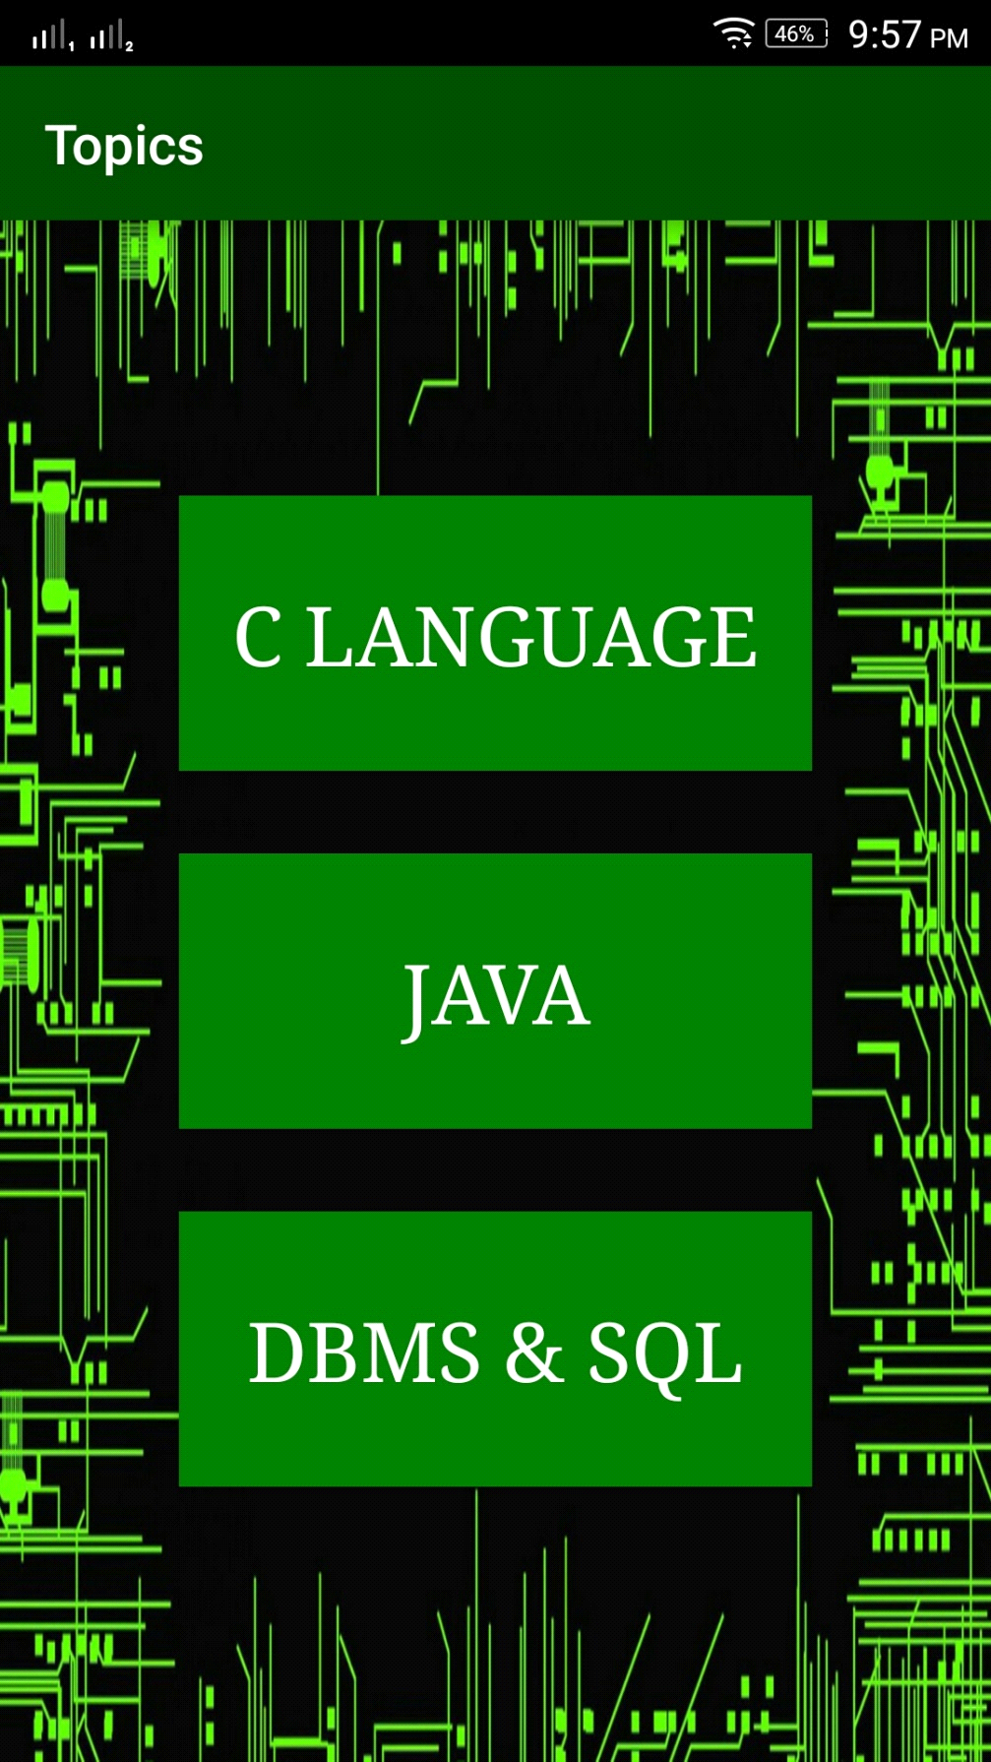
Fig.3.2
- C questions
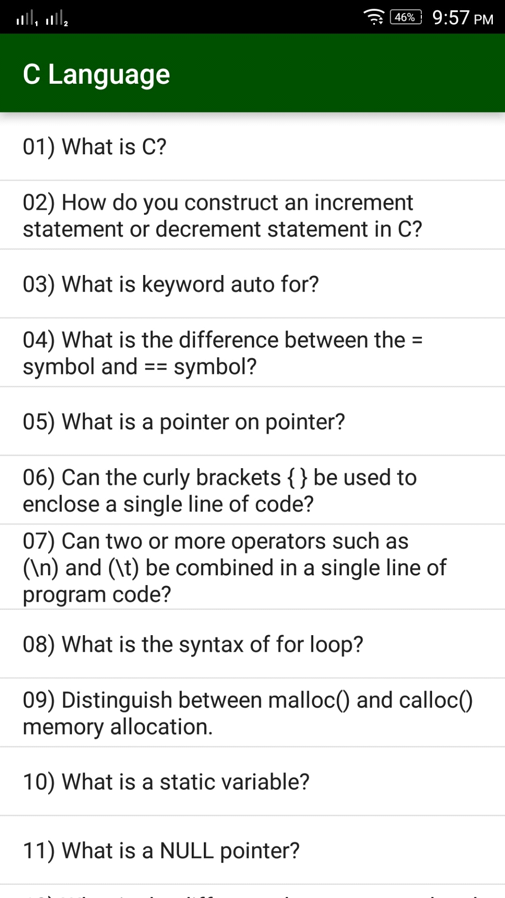
Fig.3.3
- java question:-
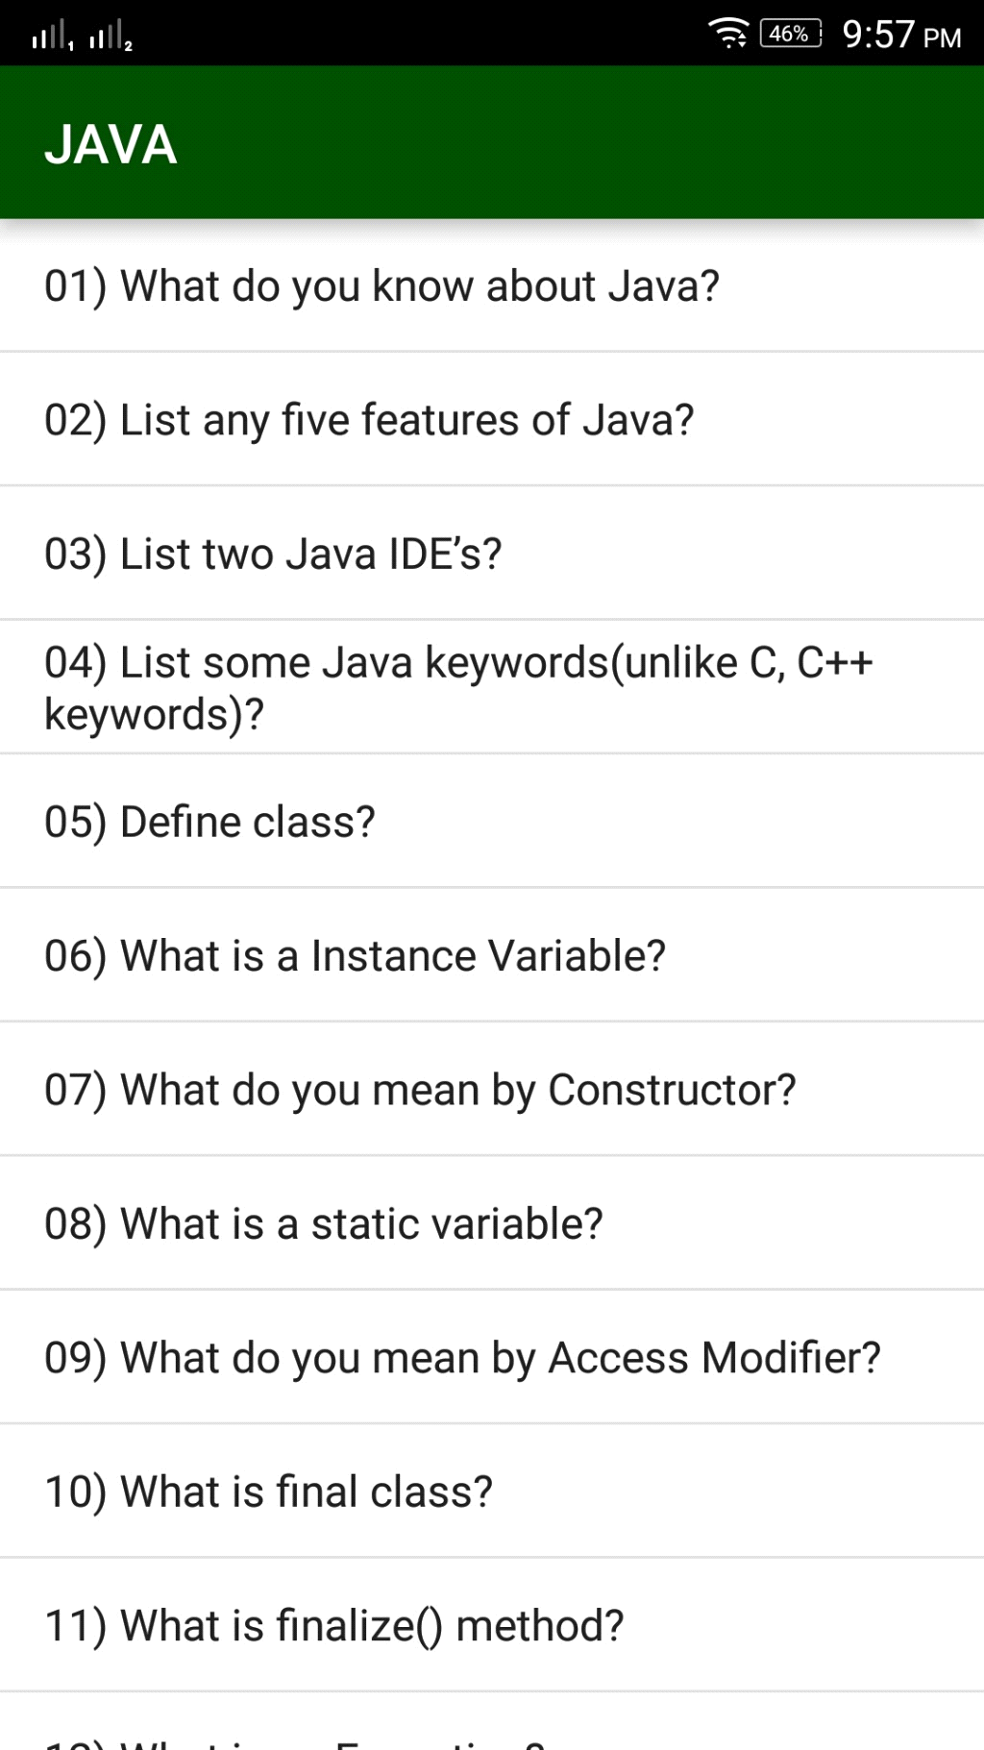
Fig.3.4
- Dbms question:-
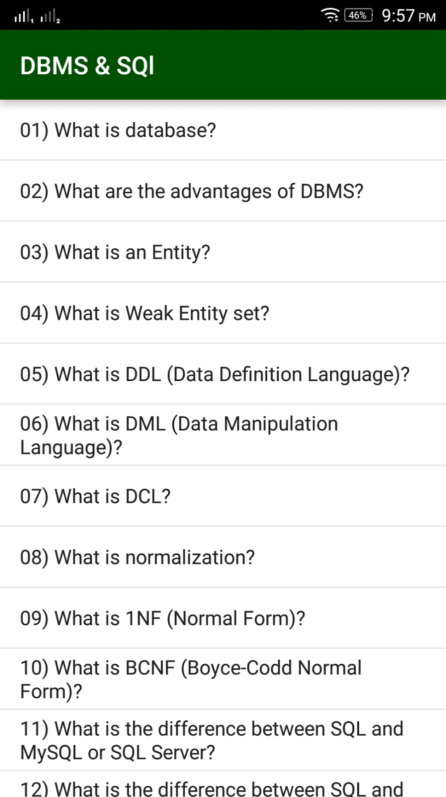
Fig.3.5
- Click on option menu to open the about app:-
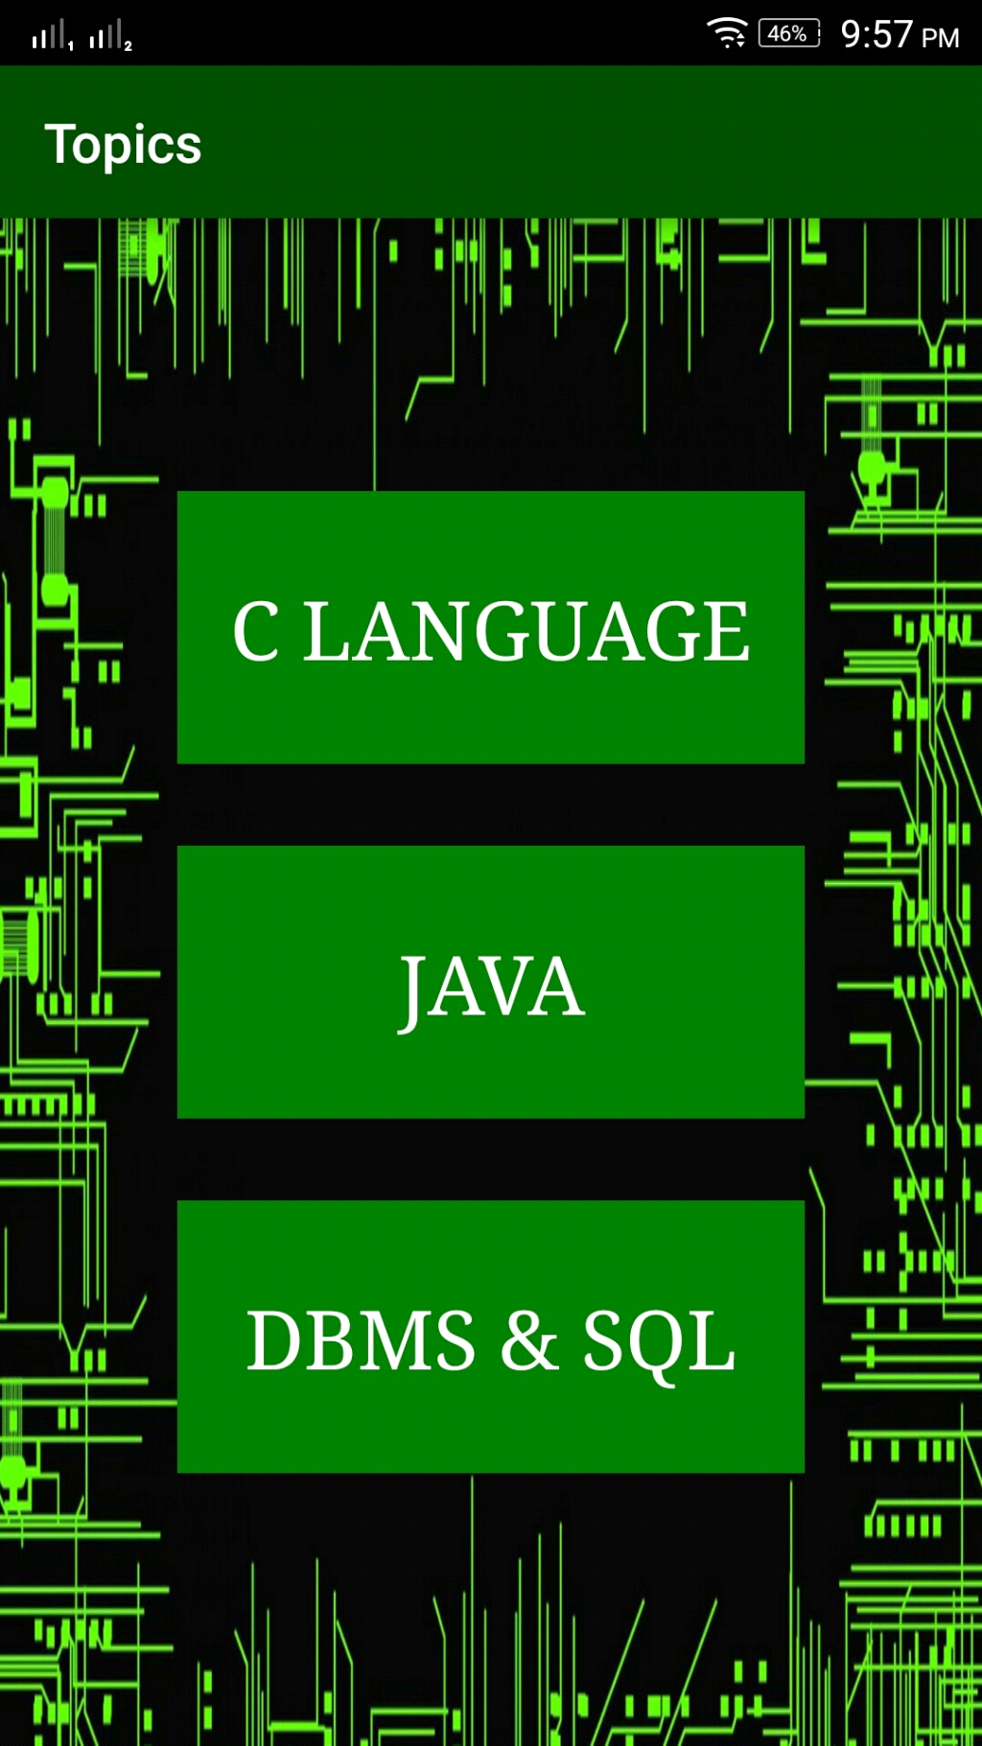
Fig.3.6
- About app:-


Fig.3.7
- Press back button to exit application:-

Fig.3.8

CHAPTER- 4
CONCLUSION
The Zidio Development Task Management System was developed to resolve the persistent issues of miscommunication, deadline management, and inefficient task handling in collaborative environments. The platform provides a unified interface for task assignment, progress tracking, document handling, and status reporting.
Key accomplishments of the system include:
- Centralized Task Management: All project-related tasks are accessible in one place, reducing confusion and eliminating scattered communications.
- Role-Based Access Control: Different interfaces and permissions for admins and users ensure secure and structured project management.
- Kanban Dashboard View: Tasks are presented in a visual flow across stages like To-Do, In Progress, and Completed, which enhances project tracking and prioritization.
- File Attachments & Previews: Each task allows associated documents and media files to be attached and previewed, making project data rich and accessible.
- Real-Time Database Sync: MongoDB integration and front-end optimizations provide a near-instantaneous update across all devices.
In conclusion, the system enhances transparency, boosts team collaboration, reduces workload duplication, and streamlines execution pipelines for small to mid-sized development teams.
  - FUTURE SCOPE

The Zidio Task Management System is designed with scalability in mind, allowing for various enhancements and integrations. Below are the detailed sub-sections showcasing the system’s promising evolution.

4.1.1 Integration with Third-Party Tools
- Integrate with Slack for instant team notifications and channel-based alerts.
- Sync with Microsoft Teams to enable collaboration during team meetings.
- Connect to Google Calendar or Outlook Calendar for event/task synchronization.
- Include integration with Zapier to automate cross-platform workflows.
- Enable GitHub/GitLab linkage to sync commit activity with tasks.

4.1.2 AI-Powered Task Recommendations
- Use ML to suggest tasks based on historical performance data.
- Predict team availability and bandwidth using AI-driven load analysis.
- Recommend deadlines based on task complexity and past resolution times.
- Provide adaptive learning algorithms to continuously refine task suggestions.
- Suggest collaboration groups based on past teamwork patterns.

4.1.3 Advanced Analytics and Reports
- Create custom report templates for different project managers or departments.
- Enable filter-based dashboards (by priority, project, employee).
- Include real-time visualizations: bar graphs, pie charts, Gantt charts.
- Track time spent on each task or module for billing or efficiency evaluation.
- Integrate automated email reporting at predefined intervals (daily, weekly, etc.).

4.1.4 Mobile Application Development
- Design native apps using React Native or Flutter for cross-platform support.
- Enable push notifications for reminders and updates.
- Offer a dark mode for better UI/UX.
- Implement offline support with local caching.
- Use biometric login (fingerprint/face ID) for secure mobile access.

4.1.5 Voice Command Features
- Integrate Google Assistant or Siri Shortcuts for voice-based commands.
- Enable hands-free navigation through tasks using NLP.
- Add voice-to-text support for task descriptions or comments.
- Train the system for context-aware voice queries (e.g., "What’s due today?").

4.1.6 Offline Mode with Auto-Sync
- Enable CRUD operations offline and auto-resolve conflicts on sync.
- Show a “sync pending” indicator for unsynced changes.
- Store offline data using IndexedDB or local storage.
- Implement differential sync for minimum data bandwidth usage.

4.1.7 Enhanced Security Protocols
- Add Two-Factor Authentication (2FA) via SMS or email.
- Support OAuth 2.0 for secure login via Google, GitHub, etc.
- Log IP addresses and unusual access patterns for risk analysis.
- Enable role-based access control (RBAC) with permission hierarchies.
- Encrypt all data-in-transit using SSL/TLS and AES encryption for at-rest data.

4.1.8 Role-Based Dashboards
- Customize dashboards for roles: Admin, Team Lead, Developer, Intern.
- Allow drag-and-drop widgets based on role-specific KPIs.
- Provide quick-access panels for pending tasks, assignments, approvals.
- Visual cues for overdue tasks, priority flags, and blockers.

4.1.9 Multi-Language Support
- Support for RTL languages (like Arabic, Hebrew).
- Detect and set language via browser locale or user profile.
- Allow dynamic switching between languages in UI.
- Translate system emails, notifications, and exports.

4.1.10 Integration with Cloud Storage
- Connect to Google Drive, Dropbox, OneDrive via OAuth.
- Enable file versioning and preview within the platform.
- Auto-upload task attachments to linked cloud folders.
- Allow direct linking and embedding of documents/spreadsheets.

4.1.11 Real-Time Collaboration and Chat
- Add a chat module within tasks for contextual discussion.
- Use WebSocket or Firebase for real-time updates.
- Show typing indicators, read receipts, and message history.
- Support emoji, @mentions, and attachments in comments.

4.1.12 Custom Workflow Automation
- Allow users to create "if-this-then-that" rules (e.g., IF task completed, THEN notify manager).
- Provide a visual workflow editor with drag-and-drop nodes.
- Schedule automated follow-ups for uncompleted tasks.
- Automate project phase transitions based on milestones.
REFERENCES
- React Official Docs
📘 https://react.dev/
- React Router (Routing without page refresh)
📘 https://reactrouter.com/
- Tailwind CSS (Utility-first styling)
🎨 https://tailwindcss.com/docs
- Material UI (MUI)
🎨 https://mui.com/material-ui/getting-started/
- MongoDB Official
🟢 https://www.mongodb.com/
- MongoDB Atlas (Cloud DB Service)
☁️ https://www.mongodb.com/atlas/database
- MDN Web Docs
📚 https://developer.mozilla.org/

